Five little pumpkins sitting on a gate! 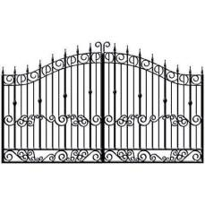
The first one said, “Oh my, it´s getting late!”
The second one said, “There are witches in the air”
The third one said, “But we don´t care!”
The fourth one said, “We are ready for some fun!”
The fifth one said, “Let´s run and run and run”
So whoooooo went the went
And out went the lights
And five little pumpkins rolled out of sight!
